**ADBMS Lab Assignment 6**

**Cursors**

Name: Dhruv Patel

PRN: 15070121112

Class: Final yr CS&E

Batch of 2015-2019



**Q1.**

**Code:**

declare cursor empCursor is

select name, designation, salary from employees where salary > 11000; nm employees.name%TYPE;

desn employees.designation%TYPE;

slry employees.salary%TYPE;

begin

open empCursor;

loop

fetch empCursor into nm, desn, slry;

exit when empCursor%notfound;

dbms_output.put_line('Employee name : ' || nm || ', designation: ' || desn

* ', salary: ' || slry); end loop;

close empCursor; end;

**Output:**

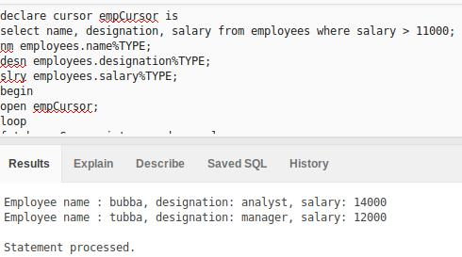

**Q2:**

**Code:**

declare cursor empCursor is

select name, designation, experience from employees where experience > 35; nm employees.name%TYPE;

desn employees.designation%TYPE;

exp employees.experience%TYPE;

begin

open empCursor;

loop

fetch empCursor into nm, desn, exp;

exit when empCursor%notfound;

dbms_output.put_line('Employee name : ' || nm || ', designation: ' || desn

* ', experience: ' || exp); end loop;

close empCursor; end;

**Output:**

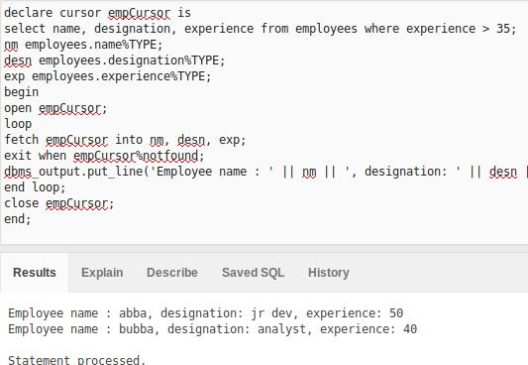

**Q3:**

**Code:**

declare cursor empCursor is

select emp_no from employees;

empno employees.emp_no%TYPE;

begin

open empCursor;

loop

fetch empCursor into empno;

exit when empCursor%notfound;

end loop;

dbms_output.put_line('Total number of employees: ' || empCursor%rowcount);

close empCursor;

end;

**Output:**

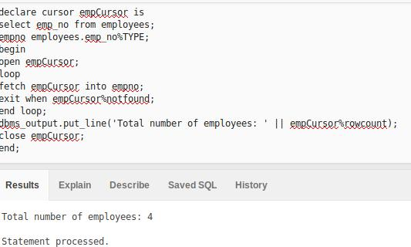

**Q4.**

**Code:**

declare cursor empCursor is

select department_no, salary from employees where department_no = 17 for update of salary;

begin

for empRec in empCursor loop

update employees set salary = salary + 1000 where current of empCursor;

end loop;

end;

**Output:**

**Table old**

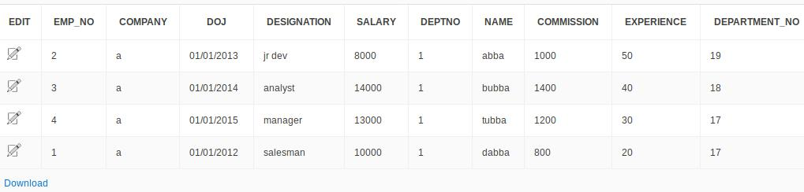

**Table new**

